***OOP Lab 2 Exercise***

### *Question # 01*:

### Write a C++ program to accept five integer values from keyword in order to print the elements of the array in reverse order using a pointer. Given the string "A string." Print on one line the letter on the index 0, the pointer position and the letter t. update the pointer to pointer +2. Then, in another line print the pointer and the letters r and g of the string (using the pointer).

### *Question # 02*:

### Write a global function called merge() that merges two sorted int arrays by first allocating memory for a dynamic array with enough room for both int arrays and then inserting the elements of both arrays into the new array in sequence. Arguments: The two int arrays and their length. Return value: A pointer to the new array.

### *Question # 03*:

Write a recursive function that receives a positive integer number and prints it on the screen in reverse order as shown below. Write a main function for testing.

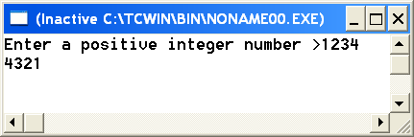

### *Question # 04*:

Write a recursive function count digits that receives an integer number and returns how many digits it contains. Write a main function to read an integer number and tests the written function count digits.

***Input: 12345***

***Output: 5 Digits***

Write a program that will read 10 integers from the keyboard and place them in an array.

### *Question # 05*:

The program then will sort the array into ascending and descending order and print the sorted list. The program must not change the original array or create any other integer arrays.

Hint: It requires two pointer arrays.

Write function divisors that receive an integer number and return its divisors using pointer array on main including 1 and itself.

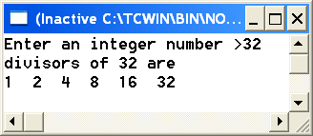

### *Question #06:*

Write a program to swap two variables by passing the reference of these variables into a function declared as void swap(int *, int *).

### *Question #07:*

A class of students took a math test. Their teacher found that the mean score on the test was an 85%. She then wants to calculate the standard deviation to confirm the mean. She ask for your help and wanted you to design a single function that receives an array of 10 integers and returns the standard deviation of these numbers without using return statement. Invoke the function in main( ) and output the result.

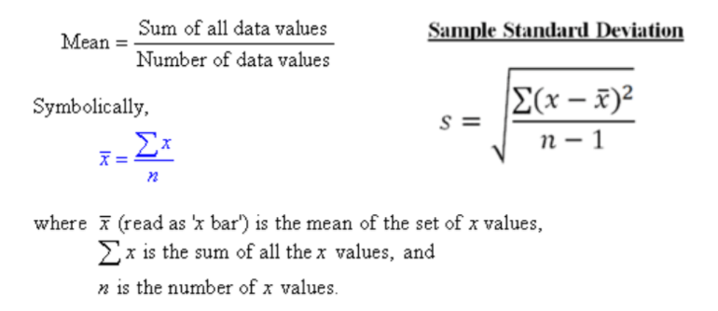

### *Question #08*

Read an array through pointer and search for how many times a certain word has occurred in the given array.  
Example:   
***Your word: is  
Search in: your task is to display the number which is given by user.  
Occurrence: 2 times***

### *Question #09:*

A zoo in Madagascar wants to keep track of how many pounds of food each of its three Pandas eats each day during a typical week. Write a program that stores this information in a two dimensional 3 × 7 array, where each row represents a different Panda and each column represents a different day of the week. The program should first have the user input the data for each Panda. Then it should create a report that includes the following information:

1. Average amount of food eaten per day by the whole family of Pandas.
2. The least amount of food eaten during the week by any one Panda.
3. The greatest amount of food eaten during the week by any one Panda.

Create three functions to perform these calculation and generate report in main (). All arguments to functions should pass by reference.

### *Question #10:*

Write a program that prompts the users to enter 12 numbers. This program reads the numbers into an array. Make another array that will store the average of numbers.

The two arrays will be passed to a function for and the average will be calculated by

1. Take First Four Numbers at index calculate their average and store at first index in Average Array.
2. Next time skip the first index number and average the next 4 Index Numbers and store at second index in Average Array.
3. And this procedure will continue, until Average for all windows will be stored in Average Array.

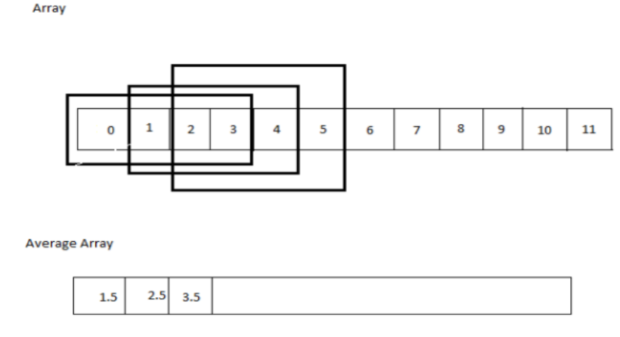

### *Question #11*

A parking garage charges a Rs. 20.00 minimum fee to park for up to three hours. The garage charges an additional Rs. 5.00 per hour for each hour or part thereof in excess of three hours. The maximum charge for any given 24-hour period is Rs. 100.00. Assume that no car parks for longer than 24 hours at a time. Write a program that calculates and prints the parking charges for each of three customers who parked their cars in this garage yesterday. You should enter the hours parked for each customer. Your program should print the results in a neat tabular format and should calculate and print the total of yesterday’s receipts. The program should use the function calculateCharges() to determine the charge for each customer.

Your outputs should appear in the following format:

**Car Hours Charge**

1 1.5 20.00

2 4.0 25.00

3 24.0 100.00

**TOTAL 29.5 145.00**

### *Question #12*

Write a program in C to print all permutations of a given string using pointers.

